**Robotics**

**Exercise 6.1. Mapping EKF**

In this exercise we are going to **build a map** consisting of **landmarks** (or features) using an algorithm based on **EKF** and *a range-bearing* sensor, provided in the exercise’s appendix.

For your convenience, it is included here the slide illustrating how the algorithm performs once the sensor takes a measurement to a landmark. Two cases are possible: the landmark is observed for first time, or the landmark was already present in the map. *Note: xEst is a vector with the coordinates of all landmarks, while pEst stores their associated uncertainty.*

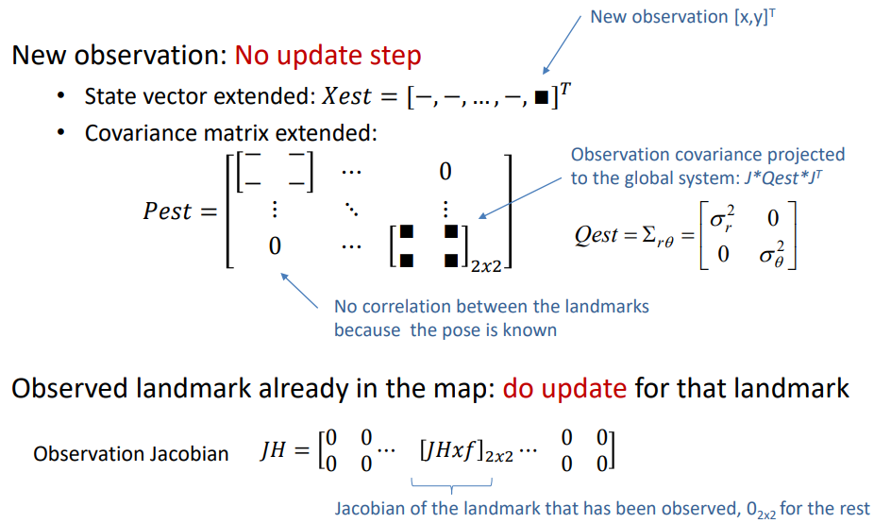

In this case we make the assumption that **the robot’s pose is known** (without uncertainty) and we want to estimate the *pdf* of the location of a number of landmarks that are present in the robot’s surroundings, utilizing for that a **noisy sensor**.

**Exercise goals:**

**1. – Complete the code.** The algorithm has gaps at some key places, so your first goal is to fill them with the appropriate code. For that, first review the code that is written and understand what is going on. Concretely, your mission is to implement the Jacobians computation, as well as some stuff related to the measurements.

**2. - Consider that only a landmark exists.** Set the variable *nFeatures* to 1. Execute the program and show the content of the vector of states *xEst* and the covariance matriz *Pest* each 5 iterations. What dimensions do they have?

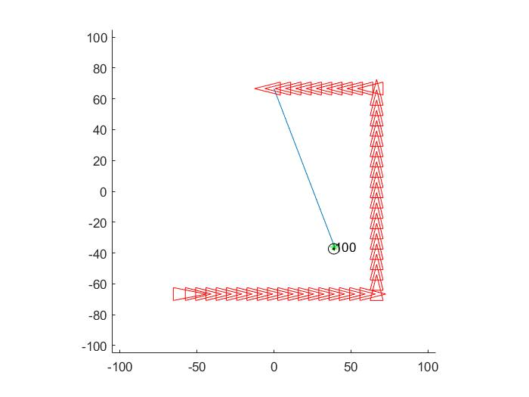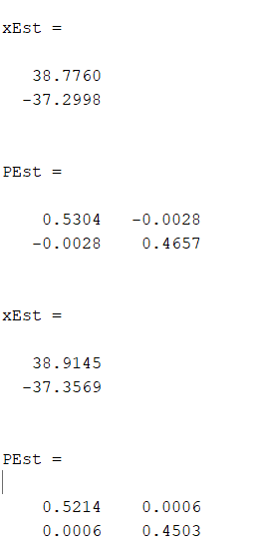

Image 1. One landmark execution Image 2.Values in the last iterations

xEst has a dimension of 2x1 and Pest, a dimension of 2x2. This is because we only have one landmark and xEst has only the position in x and y of the robot and Pest has the covariance of that only landmark.

**3. - Repeat the last point employing 5 *landmarks*.** Explain why and how the content of the variables *xEst* and *Pest* has change. Show also, each 5 iterations, the content of the jacobian of the observation (*jH*). What structure does the matrix of covariances have? Is there any kind of correlation among the observations of different *landmarks*?

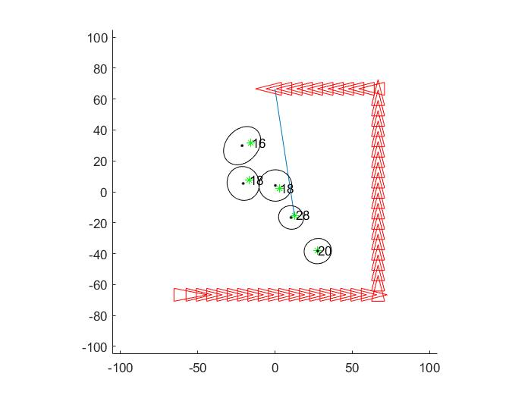

Image 3. Five landmark execution

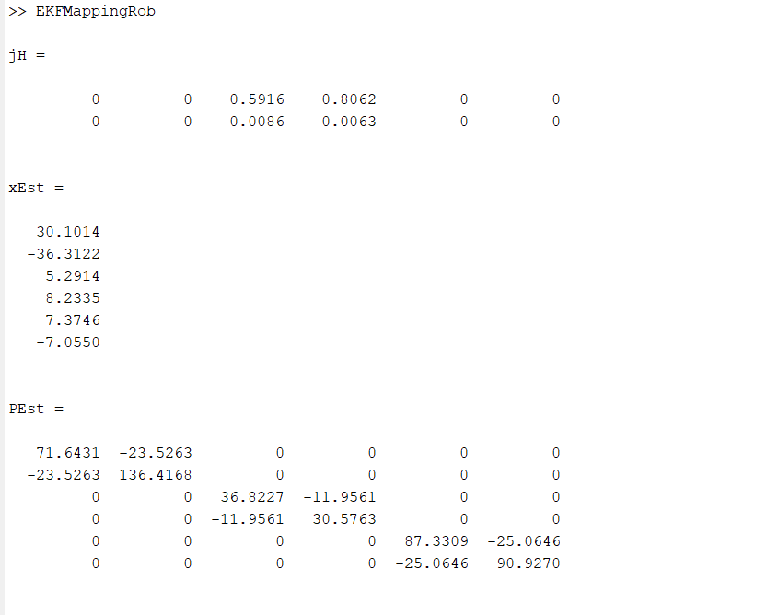 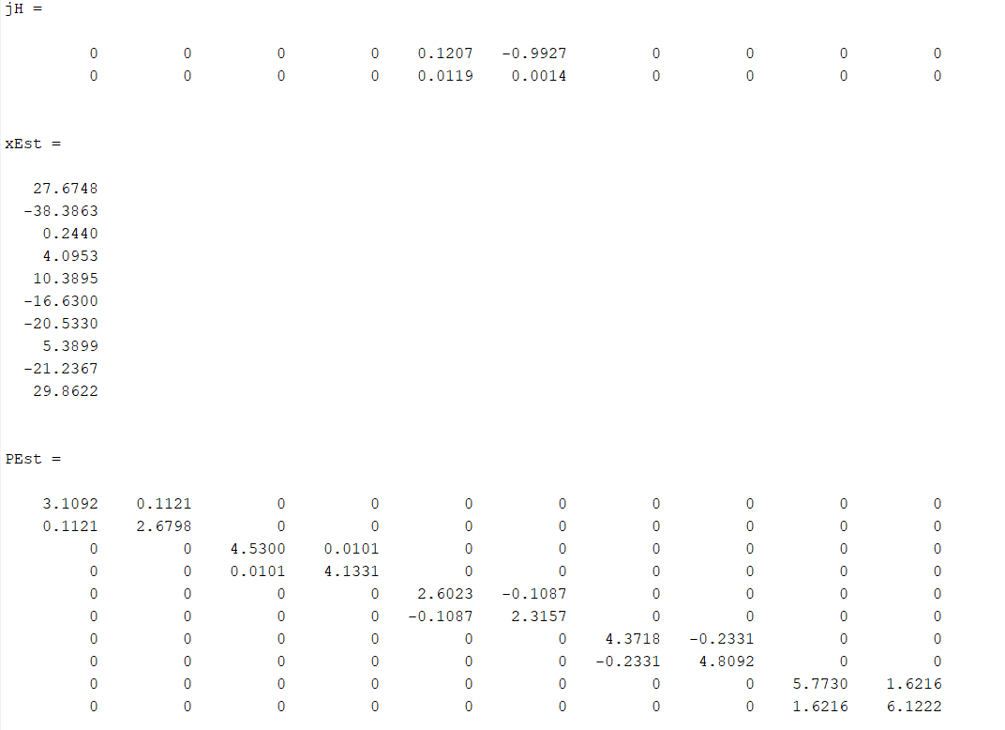

Image 4. Values in the initial iteration Image 5.Values in the final iteration

As we see from the Image 4 to Image 5, xEst and Pest change in theirs dimensions. It is due to the quantity of landmarks which has been observed by the robot. Each time the robot detects a new landmark, xEst grows in two in the rows and Pest, in two in the row and column.

jH has the structure that all the values are 0 except the indexes from the landmark observed. Also has the dimension of 2x2l, which l is the number of landmarks we already observed.

**4. - Results of the mapping process.** Modify the code to store the determinant of the covariance matrix of each landmark and the error in the fitting along the algorithm iterations. Plot it for the case of 5 *landmarks*.

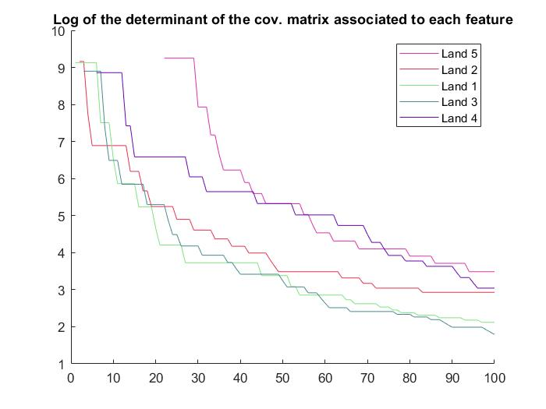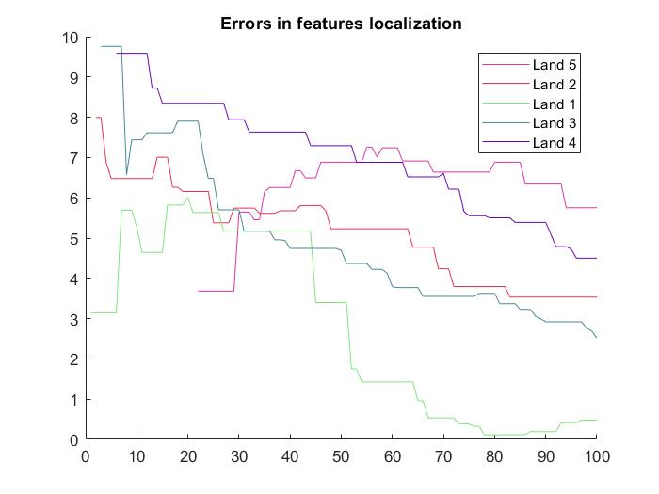

Plot 1. Covariance of each landmark Plot 2. Error in the localization of each landmark

As we see in the plots, the determinant of the covariance matrix of each landmark decrease when it is observed by the robot, however the error of the localization of each landmark can decrease or increase. Normally, in the first iterations it decreases until a point. From there, it increases and decreases the error trying to localize the landmark at a high level of precision.

**Appendix: Exercise’s code to modify**

function EKFMappingRob

clear all;

close all;

%%global variables

global Map;global nSteps;

global Reading; global ObservedTimes;

%mode = 'step_by_step';

mode = 'visualize_process';

%mode = 'non_stop';

% Num features/landmarks considered within the map

nFeatures = 5;

% Generation of the map

MapSize = 100;

Map = MapSize*rand(2,nFeatures)-MapSize/2;

% Covariances for our very bad&expensive sensor (in the system <d,theta>)

Sigma_r = 8.0;

Sigma_theta = 7*pi/180;

Q = diag([Sigma_r,Sigma_theta]).^2;

% Initial robot pose

xVehicleTrue = [-MapSize/1.5;-MapSize/1.5;0]; % We know the exact robot pose at any moment

%initial conditions - no map:

xEst = [];

PEst = []; %Covariance marix of the landmark position (2 rows per landmark)

QEst = 1.0*Q; %Covariance matrix of the measurement

% MappedFeatures relates the index of a feature from the true map and its

% place within the state (which depends on when it was observed).

MappedFeatures = NaN*zeros(nFeatures,1);

% storing the number of times a features has been seen

% also store the handler to the graphical info shown

ObservedTimes = zeros(nFeatures,2);

% Initial graphics - plot true map

figure(1); hold on; grid off;

plot(Map(1,:),Map(2,:),'g*');hold on;

axis([-MapSize-5 MapSize+5 -MapSize-5 MapSize+5]);

axis equal;

set(gcf,'doublebuffer','on'); %gcf: current figure handle

hObsLine = line([0,0],[0,0]);

set(hObsLine,'linestyle',':');

% Loop configuration

nSteps = 100; % Number of motions

turning = 40; % Number of motions before turning (square path)

% Control action

u=zeros(3,1);

u(1)=(2*MapSize/1.5)/turning;

u(2)=0;

PFeatDetStore = NaN*zeros(nFeatures,nSteps);

FeatErrStore = NaN*zeros(nFeatures,nSteps);

for i_feat = 1:nFeatures

colors(i_feat,:) = [rand rand rand];

end

% Start the loop!

for k = 1:nSteps

%

% Move the robot

%

u(3)=0;

if (mod(k,turning)==0) u(3)=pi/2;end;

xVehicleTrue = tcomp(xVehicleTrue,u); % Perfectly known robot pose

% We assume that the map is static (the state transition model of

xPred = xEst;

PPred = PEst;

%

% Observe a randomn feature

%

[z,iFeature] = getRandomObservationFromPose(xVehicleTrue,Map,Q);

% Update the "observedtimes" for the feature and plot the reading

ObservedTimes(iFeature)=ObservedTimes(iFeature)+1;

PlotNumberOfReadings(xVehicleTrue,iFeature,Map);

% Have we seen this feature before?

if( ~isnan(MappedFeatures(iFeature)) ) %Yes, it is already in the map

%

% Predict observation

%

% Find out where it is in state vector

FeatureIndex = MappedFeatures(iFeature);

% xFeature is the current estimation of the position of the

% landmard "FeatureIndex"

xFeature = xPred(FeatureIndex:FeatureIndex+1);

% Predicts the observation

zPred = getRangeAndBearing(xVehicleTrue,xFeature); % Hint: use getRangeAndBearing function

% Get observation Jacobians

jHxf = GetObsJacs(xVehicleTrue,xFeature);

% Fill in state jacobian

% (the jacobian is zero except for the observed landmark)

jH=zeros(2,nStates+2);

jH(:,FeatureIndex:FeatureIndex+1)=jHxf;

if mod(k,5)==0 && nFeatures>1

jH

end

%

% Kalman update

%

Innov = z-zPred; % Innovation

Innov(2) = AngleWrap(Innov(2));

S = jH*PPred*jH'+QEst;

K = PPred*jH'*inv(S); % Gain

xEst = xPred+ K*Innov;

PEst = PPred-K*S*K';

%ensure P remains symmetric

PEst = 0.5*(PEst+PEst');

else % No in the current map (state)

% This is a new feature, so add it to the map

nStates = length(xEst); %dimension 2x#landmarks_in_map

% The observation is in the local frame of the robot, it has to

% be translated to the global frame

xFeature = xVehicleTrue(1:2)+FeatureCR;

% Add it to the current state

xEst = [xEst;xFeature]; %Each new feature two new rows

% Compute the jacobian

jGz = GetNewFeatureJacs(xVehicleTrue,z); %Dimension 2x2

M = [eye(nStates), zeros(nStates,2);% note we don't use jacobian w.r.t vehicle since the pose doesn’t have uncertainty

zeros(2,nStates) , jGz];

PEst = M*blkdiag(PEst,QEst)*M';

%THis can also be done directly PEst = [PEst,zeros(nStates,2);

% zeros(2,nStates), jGz*QEst*jGz']

%remember this feature as being mapped: we store its ID for the state vector

MappedFeatures(iFeature) = length(xEst)-1; %Always an odd number

end;

% Drawings

pause(0.005);

if mod(k,5)==0

xEst

PEst

end

if(mod(k,2)==0)

%xEst

%PEst

DrawRobot(xVehicleTrue,'r');%plot(xVehicleTrue(1),xVehicleTrue(2),'r*');

DoMapGraphics(xEst,PEst,5); % Draw estimated poitns (in black) and ellipses

axis([-MapSize-5 MapSize+5 -MapSize-5 MapSize+5]); % Set limits again

drawnow;

if strcmp(mode,'step_by_step')

pause;

elseif strcmp(mode,'visualize_process')

pause(0.2);

elseif strcmp(mode,'non_stop')

% non stop!

end

end;

end;

figure(2); hold on;

title('Errors in features localization');

figure(3); hold on;

title('Log of the determinant of the cov. matrix associated to each feature');

for i=1:nFeatures

figure(3)

h = plot(log(PFeatDetStore(i,:)));

set(h,'Color',colors(i,:));

figure(2)

h = plot(FeatErrStore(i,:));

set(h,'Color',colors(i,:));

end

num=[repmat('Land ',nStates/2+1,1) num2str((MappedFeatures+1)/2)];

figure(2);legend(num);

figure(3);legend(num);

end

%-------------------------------------------------------------------------%

function [z,iFeature] = getRandomObservationFromPose(xVehicleTrue,Map,Q)

iFeatures = size(Map,2);

iFeature = randi(iFeatures);

feature = Map(:,iFeature);

z = getRangeAndBearing(xVehicleTrue,feature,Q);

end

%-------------------------------------------------------------------------%

function z = getRangeAndBearing(xVehicleTrue,feature,Q)

Delta_x = feature(1,:) - xVehicleTrue(1);

Delta_y = feature(2,:) - xVehicleTrue(2);

z(1,:) = sqrt(Delta_x.^2 + Delta_y.^2); % Range

z(2,:) = atan2(Delta_y,Delta_x) - xVehicleTrue(3); % Bearing

z(2,:) = AngleWrap(z(2,:));

if nargin == 3

z = z + sqrt(Q)*rand(2,1); % Adding noise

end

end

%-------------------------------------------------------------------------%

function [jHxf] = GetObsJacs(xPred, xFeature)

diff=xFeature-xPred(1:2);

d=pdist2(xFeature',xPred(1:2)');

jHxf=-[-diff(1)/d -diff(2)/d;

diff(2)/(d^2) -diff(1)/(d^2)];

end

%-------------------------------------------------------------------------%

function [jGz] = GetNewFeatureJacs(Xv, z)

alpha = z(2) + Xv(3);

ca=cos(alpha); sa=sin(alpha);

r=z(1);

jGz = [ca -r*sa;

sa r*ca];

end

%-------------------------------------------------------------------------%

function PlotNumberOfReadings(xVehicleTrue,iFeature,Map)

global Reading;

global ObservedTimes;

for c=1:length(Reading)

if (~isnan(Reading(c)))

delete(Reading(c));

end;

end

Reading=zeros(length(iFeature));

if (ObservedTimes(iFeature,2)~=0) delete(ObservedTimes(iFeature,2));end;

ObservedTimes(iFeature,2)=text(Map(1,iFeature)+rand(), ...

Map(2,iFeature)+rand(),sprintf('%d',ObservedTimes(iFeature,1)));

for c=1:length(iFeature)

if (iFeature(c)~=-1)

Reading(c)=line([xVehicleTrue(1), Map(1,iFeature(c))], ...

[xVehicleTrue(2), Map(2,iFeature(c))]);

else

Reading(c)=NaN;

end

end

end

%-------------------------------------------------------------------------%

function DoMapGraphics(xMap,PMap,nSigma)

persistent k;

persistent handler_ellipse; %%cga animating ellipses

persistent handler_state; %%cga animating ellipses

if(isempty(k))

k = 0;

end;

k = k+1;

% removing ellipses from the previous iteration

if isempty(handler_ellipse)

handler_ellipse=zeros(length(xMap));

else

for i=1:length(handler_ellipse)

if (handler_ellipse(i)~=0)

delete (handler_ellipse(i));

end

end

end

% removing state from the previous iteration

if (isempty(handler_state))

handler_state=zeros(length(xMap));

else

for i=1:length(handler_state)

if (handler_state(i)~=0)

delete (handler_state(i));

end

end

end

handler_ellipse=zeros(length(xMap));

handler_state=zeros(length(xMap));

colors = 'kkkk';

for i = 1:length(xMap)/2

iL = 2*i-1; iH = 2*i;

x = xMap(iL:iH);

P = PMap(iL:iH,iL:iH);

handler_ellipse(i)= PlotEllipse(x,P,nSigma,'k');

handler_state(i)= plot(x(1),x(2),'k.');

c = colors(mod(i,4)+1);

set(handler_ellipse(i),'color',char(c));

% plot3(x(1),x(2),k,'r+');

end

end

%-------------------------------------------------------------------------%

function d = Determinants(Covar,LandObs)

% Covar = Covariances of each landmark and the robot

% LandObs = Vector of landmarks observed

d=NaN*ones(length(LandObs),1);

for i=1:length(LandObs)

pos=LandObs(i);

if(~isnan(pos))

cov = Covar(pos:pos+1,pos:pos+1);

d(i) = det(cov);

end

end

end

%-------------------------------------------------------------------------%

function error = Errors(EstLand,LandObs,NLandObs)

% EstLand = Estimated position of each landmark and the robot

% LandObs = Vector of landmarks observed

global Map;

error=NaN*ones(length(LandObs),1);

for i=1:length(LandObs)

pos=LandObs(i);

if(~isnan(pos))

land=Map(:,i)';

est=EstLand(pos:pos+1)';

error(i)=pdist2(land,est);

end

end

end